SIMATS ENGINEERING
ASSESSMENT TOOL 2

COURSE CODE: CSA14 COURSE NAME: Compiler Design

COURSE OUTCOME COVERED

CO1: Apply lexical analysis for token specification and recognition using LEX tool (BL3)

Assessment Tool Weightage: 20%

QUESTIONS: 3 Total Marks:50

Annexure A

ERROR ANALYSIS TASK

Code of Conduct:

I B.HEMANJALI (192525457) certify that this submission is my original work and that I have adhered to the guidelines specified for this assessment.
I understand that any violation of academic integrity rules will result in disciplinary action.

Signature of the student:

B.HEMANJALI

Annexure A

RUBRICS FOR CALCULATION:

Criteria | Weightage | Level 4 (Exemplary) | Level 3 (Proficient) | Level 2 (Developing) | Level 1 (Beginning)
Error Identification | 20% | Accurately identifies all errors with clear understanding of issues | Identifies most errors with minor omissions | Identifies limited errors; some are missed | Fails to identify key errors
Root Cause Analysis | 30% | Clearly explains underlying causes with strong technical reasoning | Explains causes with moderate clarity | Partial explanation; weak reasoning | Unable to identify causes of errors
Correction & Justification | 25% | Provides correct solutions with strong justification and logic | Provides correct corrections with some justification | Corrections are partially correct or weakly justified | Incorrect or no corrections provided
Application of Concepts | 15% | Effectively applies relevant concepts to analyze and resolve errors | Applies concepts with minor errors | Limited application; requires guidance | Unable to apply concepts
Clarity & Presentation | 10% | Presents analysis clearly, logically, and systematically | Generally clear with minor issues | Lacks clarity or proper structure | Poor presentation and difficult to understand

ERROR ANALYSIS TASK

1. ERROR ANALYSIS TASK
The given C program is intended to perform arithmetic operations, function calls, array access, and looping constructs. However, it contains errors belonging to different phases of compilation such as syntax, semantic, logical, and runtime errors.

(a) Error Identification
The following errors are present in the given program:
Line No. | Error | Nature of  Error | Description
51 | i <= n | Logical / Runtime | The loop accesses arr[n], which is outside the valid array range.
52 | arr[i] | Runtime | When i = n, an out-of-bounds array access occurs.
58 | Missing ; | Syntax | The array declaration is not terminated with a semicolon.
61 | sumArray(arr) | Semantic | The function requires two arguments: arr and n, but only one is supplied.
64 | Missing ; | Syntax | The printf() statement does not end with a semicolon.
68 | a / b where b = 0 | Runtime | Division by zero occurs during execution.
71 | *p = 20 | Runtime | p is an uninitialized pointer and does not point to a valid memory location.

(b) Classification of Errors
The errors in the given program are classified into the following categories:
1. Lexical Errors
No lexical errors are present in the given program.
All keywords, identifiers, constants, operators, and other tokens are formed correctly. Therefore, the lexical analyzer can recognize the tokens successfully.

2. Syntax Errors
Syntax errors occur when the program does not follow the grammatical rules of the C language.
Line No. | Error | Reason
58 | Missing semicolon ; | The array declaration is not terminated properly.
64 | Missing semicolon ; | The printf() statement is not terminated properly.

3. Semantic Errors
Semantic errors occur when the syntax may look correct, but the statement does not follow the meaning or type rules of the program.
Line No. |  | Error |  | Reason
61 |  | Incorrect function call |  | sumArray() requires two arguments, but only arr is passed.
4. Logical Errors
A logical error occurs when the program's instructions are syntactically valid but the logic produces an incorrect result or behavior.
Line No. | Error | Reason
51 | Incorrect loop condition i <= n | The loop should stop before i reaches n.

5. Runtime Errors
Runtime errors occur while the program is executing.
Line No. | Error | Reason
52 | Array out-of-bounds access | arr[n] may be accessed because of the incorrect loop condition.
68 | Division by zero | b is initialized to 0, so a / b is invalid.
71 | Invalid pointer dereference | p is uninitialized and does not point to a valid memory location.

(c) Compilation Behavior (Evaluation Level)
1. Errors Detected During Compilation
The following errors can be detected during the compilation phase:
- Line 58: Missing semicolon after the array initialization.
- Line 64: Missing semicolon after the printf() statement.
- Line 61: Incorrect number of arguments passed to the sumArray() function.
These errors prevent the program from compiling successfully until they are corrected.
2. Errors Detected During Execution
The following errors may occur during program execution:
- Line 51–52: Array out-of-bounds access: The loop condition i <= n allows the program to access an element outside the array.
- Line 68: Division by zero: The expression a / b attempts to divide 10 by 0.
- Line 71: Invalid pointer access: The uninitialized pointer p is dereferenced without pointing to a valid memory location.
These problems can lead to undefined behavior, incorrect results, or program termination.
3. How Early-Stage Errors Prevent Later Error Detection
Compilation is performed in different phases. Each phase processes the output of the previous phase.
- Lexical Analysis: Converts source code into tokens.
- Syntax Analysis: Checks whether tokens follow C language grammar.
- Semantic Analysis: Checks types, declarations, and function usage.
- Intermediate Code Generation: Produces an intermediate representation of the program.
- Code Optimization: Improves the efficiency of the code.
- Code Generation: Produces target or machine code.
(d) Code Correction (Application level)
The given program contains syntax, semantic, logical, and runtime errors. The following corrected C program removes these errors and executes safely.
Corrected C Program
#include <stdio.h>
int sumArray(int arr[], int n)
{
int i, sum = 0;
for (i = 0; i < n; i++)
{
sum = sum + arr[i];
}
return sum;
}
int main()
{
int arr[5] = {1, 2, 3, 4, 5};
int total;
total = sumArray(arr, 5);
if (total == 15)
{
printf("Correct Sum\n");
}
int a = 10, b = 2;
int c = a / b;
printf("Division Result = %d\n", c);
int value = 20;
int *p = &value;
printf("Pointer Value = %d\n", *p);
return 0;
}

Output:
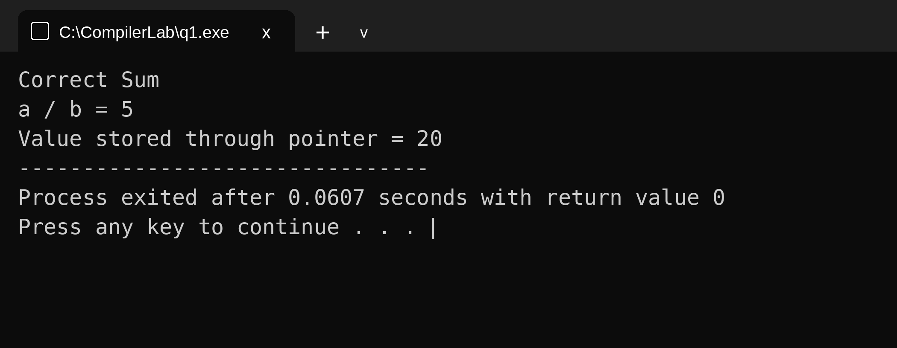
Correct Sum
a / b = 5
Value stored through pointer = 20
(e) Impact Analysis
1. Impact of Division by Zero
When b = 0, the expression a / b causes undefined behavior. It may terminate the program abnormally.
2. Impact of Improper Pointer Usage
An uninitialized pointer may access an invalid memory location, causing a segmentation fault or memory corruption.
3. Impact of Infinite Loops
An incorrect loop condition may cause repeated execution without termination, consuming CPU time and making the program unresponsive.
(f) Advanced Compiler Perspective
1. Better Error Messages
A compiler should display clear error messages with the line number, error type, cause, and suggested correction. This helps programmers identify and fix errors easily.
2. Early Detection of Runtime Errors
A compiler can use static analysis to detect possible division by zero, uninitialized pointers, and array-bound violations before execution.
3. Enhancement 1 – Static Analysis
Static analysis examines source code without executing it and warns about potential errors, unused variables, and unsafe memory access.

4. Enhancement 2 – Improved Debugging Tools
Integrating breakpoints, variable monitoring, stack traces, and memory checking helps programmers locate errors and correct them efficiently.
━━━━━━━━━━━━━━━━━━━━━━━━━━━━━━━━━━━━━
Q2. LEXICAL ERROR ANALYSIS
(a) Error Identification
The given C program contains multiple lexical errors caused by invalid identifiers, malformed constants, illegal symbols, and incorrectly formed string and character literals. These errors violate the rules of token formation in C.

Line No. | Invalid Token / Code | Error
130 | 1num | Identifier starts with a digit
131 | rate@ | Illegal character @ in identifier
132 | 'abc' | Character constant contains multiple characters
133 | 50$20 | Illegal character $ in numeric expression
134 | num#1 | Illegal character # in identifier
135 | %count | % cannot start an identifier
137 | "Welcome to Compiler Design); | Missing closing double quotation mark
139 | 09 | Invalid octal integer constant
140 | 0xZ12 | Invalid hexadecimal constant
141 | 12.3.4 | Malformed floating-point constant
143 | "Hello; | Missing closing double quotation mark
147 | invalid-id | Hyphen is not allowed in an identifier
149 | 5..6 | Malformed floating-point constant
150 | 10@5 | Illegal character @ in numeric expression
152 | 'xy' | Character constant contains multiple characters
153 | 3value | Identifier starts with a digit

(b) Error Classification
Each lexical error in the given program violates a specific rule of token formation.

Invalid Token | Rule Violated | Reason
1num | Identifier rules | Identifier cannot start with a digit.
rate@ | Identifier rules | Special character @ is not allowed.
'abc' | Character literal rules | Contains more than one character.
50$20 | Operator/symbol rules | $ is not a valid C operator.
num#1 | Identifier rules | # is not allowed inside an identifier.
%count | Identifier rules | % cannot start an identifier.
"Welcome to Compiler Design); | String literal rules | Closing double quotation mark is missing.
09 | Constant formation | Invalid octal constant; octal digits range from 0 to 7.
0xZ12 | Constant formation | Z is not a valid hexadecimal digit.
12.3.4 | Constant formation | Contains two decimal points.
"Hello; | String literal rules | Closing double quotation mark is missing.
invalid-id | Identifier rules | Hyphen is not allowed in an identifier.
5..6 | Constant formation | Malformed floating-point constant.
10@5 | Operator/symbol rules | Illegal symbol @ is used.
'xy' | Character literal rules | Contains multiple characters.
3value | Identifier rules | Identifier cannot start with a digit.

(c) Token Correction
The invalid tokens in the given program are replaced with valid tokens according to the lexical rules of the C programming language.
Invalid Token | Corrected Token
1num | num1
rate@ | rate
'abc' | 'a'
50$20 | 50+20
num#1 | num1
%count | count
"Welcome to Compiler Design); | "Welcome to Compiler Design");
09 | 9
0xZ12 | 0x12
12.3.4 | 12.34
"Hello; | "Hello"
invalid-id | invalid_id
5..6 | 5.6
10@5 | 10+5
'xy' | 'x'
3value | value3

(d) Compiler Behavior Analysis
1. How a Lexical Analyzer Processes Errors
A lexical analyzer (scanner) reads the source code character by character and groups characters into tokens such as keywords, identifiers, operators, and constants. It identifies invalid tokens that do not follow the lexical rules of C.
2. Does the Compiler Stop Immediately?
The compiler does not always stop immediately after finding a lexical error. Its behavior depends on the compiler and its error-recovery mechanism.
- Stops immediately: Some compilers stop processing when a serious lexical error is encountered.
- Continues scanning: Other compilers report the error, skip invalid characters or tokens, and continue scanning to identify additional errors.
(e) Advanced Thinking
1. DFA Rule to Detect Identifiers Starting with Digits
A valid C identifier must begin with a letter or underscore, followed by letters, digits, or underscores.
Rule:
Valid: [A-Za-z_][A-Za-z0-9_]*
Invalid: [0-9][A-Za-z0-9_]*
For example, 1num is invalid because it starts with a digit, whereas num1 is valid.
2. Improving Error Messages for Beginners
Compilers can improve error messages by providing:
- Exact line and column numbers.
- Simple explanations of the error.
- The invalid token and the reason it is invalid.
- Suggested corrections with examples.
Example:
Error at line 130: Invalid identifier '1num'.
Identifiers cannot start with digits.
Suggestion: Use 'num1'.
Corrected Code
#include <stdio.h>

int main() {
int num1 = 100;
float rate = 25.5;
char ch = 'a';
int total = 50 + 20;
int num_1 = 30;
int count = 40;
printf("Welcome to Compiler Design\n");
int x = 9;
int y = 0x12;
float z = 12.34;
char str1[] = "Hello";
char str2[] = "World";
int _valid = 10;
int invalid_id = 20;
float value = 5.6;
int data = 10 + 5;
char c = 'x';
int value3 = 60;
printf("Value: %d\n", total);
printf("%d %.1f %c %d %d %d %d %.2f\n", num1, rate, ch, num_1, count, x, y, z);
printf("%s %s %d %d %.1f %d %c %d\n", str1, str2, _valid, invalid_id, value, data, c, value3);
return 0;
}
Output
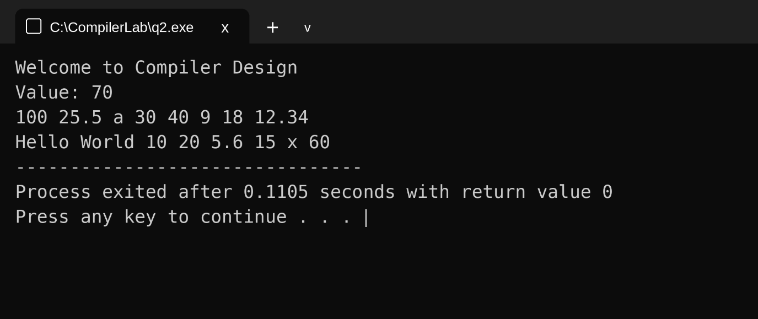
Welcome to Compiler Design
Value: 70
100 25.5 a 30 40 9 18 12.34
Hello World 10 20 5.6 15 x 60

Q3. MULTI-PHASE ERROR ANALYSIS
(a) Error Identification
The given C program contains errors in syntax, lexical analysis, function calls, expression handling, optimization, and runtime execution.
Line No. | Error | Description
198 | Missing ; | The return a / b statement lacks a semicolon.
202 | int #value | # is an invalid character in an identifier.
203 | Missing ; | The declaration float num = 15.5 lacks a semicolon.
206 | divide(10) | The function requires two arguments, but only one is supplied.
208 | if(result = 5) | Assignment operator = is used instead of comparison operator ==.
209 | Missing ; | The printf() statement lacks a semicolon.
214 | x / y | Division by zero occurs because y = 0.
219 | arr[4] | Array index is out of bounds because valid indices are 0–3.
222 | *ptr = 25 | The uninitialized pointer is dereferenced.
225 | x + y * result + 0 | Adding zero is redundant and can be optimized.
227–229 | while(x < 20) | The value of x never changes, resulting in an infinite loop.

(b) Classification by Compiler Phase
The errors in the given program are classified into the following compiler phases.
1. Lexical Errors
Line 202: int #value = 20;
The symbol # is invalid within an identifier. It should be replaced with a valid identifier, such as value.
2. Syntax Errors
- Line 198: Missing semicolon after return a / b.
- Line 203: Missing semicolon after float num = 15.5.
- Line 209: Missing semicolon after the printf() statement.
These errors violate the syntax rules of the C language.
3. Semantic Errors
Line 206: result = divide(10);
The function divide() requires two arguments, but only one is provided. The function call must supply both arguments.
4. Intermediate Code Generation Issues (Logic/Precedence)
Line 225: total = x + y * result + 0;
The multiplication operator has higher precedence than addition. The compiler must preserve this order when generating intermediate code.
5. Optimization Issues
Line 225: The addition of 0 is redundant. The compiler can remove this unnecessary operation without changing the expression's value.
6. Runtime Errors
- Line 214: Division by zero occurs because y = 0.
- Line 219: arr[4] accesses an element outside the array bounds.
- Line 222: Dereferencing the uninitialized pointer ptr may cause invalid memory access.
7. Logical Errors
- Line 208: if(result = 5) assigns a value instead of comparing it. Use if(result == 5).
- Lines 227–229: The loop does not increment x, so it may continue indefinitely when the condition is true.
(c) Compilation vs Execution (Evaluation)
1. Errors Detected at Compile Time
The following errors can be detected during compilation:
- Line 198: Missing semicolon after the return statement.
- Line 202: Invalid identifier containing #.
- Line 203: Missing semicolon after variable declaration.
- Line 206: Incorrect number of arguments passed to divide().
- Line 209: Missing semicolon after the printf() statement.
These errors must be corrected for successful compilation.
2. Errors Detected During Execution
- Line 214: Division by zero may cause undefined behavior.
- Line 219: Accessing arr[4] causes an out-of-bounds array access.
- Line 222: Dereferencing an uninitialized pointer may cause a program crash.
- Lines 227–229: The loop may execute indefinitely because x is not updated.
3. Why Some Errors Prevent Further Compilation
Compilation occurs in multiple phases. Syntax errors prevent the compiler from correctly parsing the program, while lexical errors may prevent valid token formation. Consequently, semantic analysis and later compilation phases may be affected.
(d) Fully Corrected Program
#include <stdio.h>

int divide(int a, int b) {
if (b == 0) {
printf("Error: division by zero\n");
return 0;
}
return a / b;
}

int main() {
int value = 20;
float num = 15.5;
int result;
result = divide(10, 2);
if (result == 5) {
printf("Result is 5\n");
}
int x = 10;
int y = 0;
int z = divide(x, y);
int arr[4] = {1, 2, 3, 4};
printf("%d\n", arr[3]);
int number = 25;
int *ptr = &number;
*ptr = 25;
int total;
total = x + (y * result);
printf("value=%d num=%.1f z=%d ptr=%d total=%d\n", value, num, z, *ptr, total);
while (x < 20) {
printf("%d\n", x);
x++;
}
return 0;
}
Output
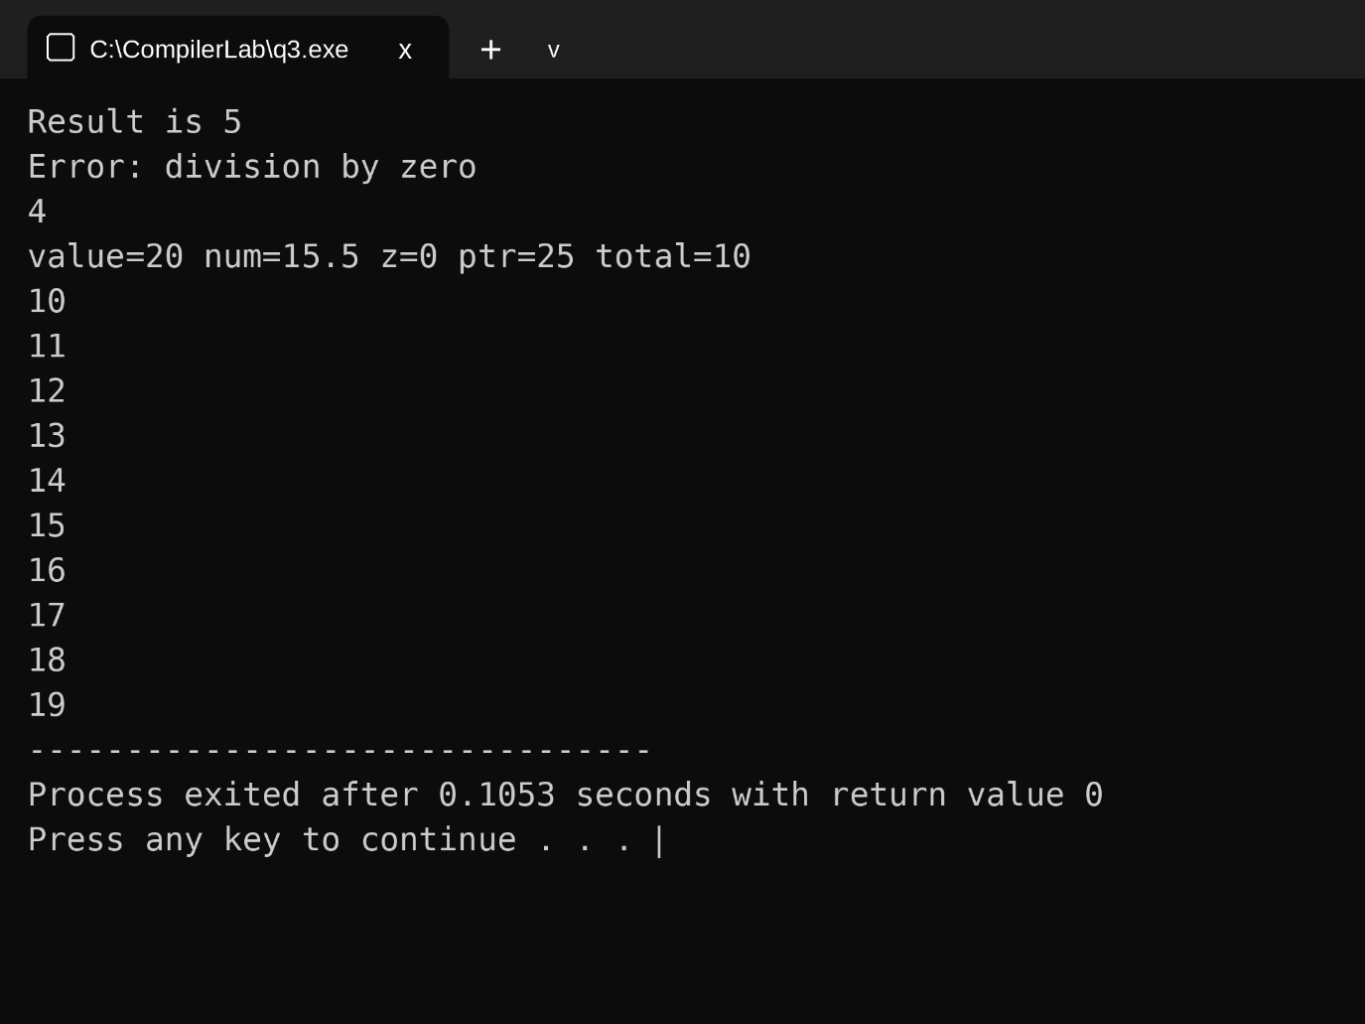
Result is 5
Error: division by zero
4
value=20 num=15.5 z=0 ptr=25 total=10
10
11
12
13
14
15
16
17
18
19
(e) Deep Analysis (Evaluation Level)
1. Impact of Incorrect Pointer Usage
An uninitialized pointer does not contain a valid memory address. Dereferencing it may cause a segmentation fault, memory corruption, or unpredictable program behavior. Initializing the pointer with a valid address prevents this problem.
2. Impact of Array Bounds Violation
The array arr[4] contains four elements, with valid indices from 0 to 3. Accessing arr[4] reads outside the array bounds, resulting in undefined behavior and possibly incorrect output or a program crash.
3. Impact of Operator Precedence on Intermediate Code
In the expression:
total = x + y * result + 0;
Multiplication has higher precedence than addition. Therefore, y * result is evaluated first, followed by addition with x. The compiler must preserve this order when generating intermediate code. The redundant + 0 can be removed during optimization without changing the result.
(f) Advanced Task (Create Level)
1. Improvements to Detect Runtime Errors Earlier
Static Analysis: A compiler can analyze the source code without executing it to identify potential errors such as division by zero, uninitialized pointers, and array-bound violations.
Runtime Checking: The compiler can insert checks to detect invalid memory access and array-bound violations during execution, helping prevent unexpected program failures.
2. Improvements to Debugging Messages
A compiler should provide clear error messages containing the line number, error type, cause, and suggested correction. This helps programmers locate and fix errors quickly.
3. Removing Redundant Expressions Through Optimization
The compiler optimizer can simplify unnecessary expressions without changing the program's result.
Example:
total = x + y * result + 0;
Optimized expression:
total = x + y * result;
The redundant addition of zero is removed, making the expression simpler.

